Quant Assign 1

**Create an R script. You may choose what the script does, but at the minimum should demonstrate the following:**

**1) Read a file for data**

**2) Produce summary statistics of the data**

**3) Produce a graph**

**4) That it works**

library(tidyverse)

## -- Attaching packages --------------------------------------- tidyverse

setwd("~/R_KSU/Quant")  
  
data <- read_csv('Data.csv')  
## -- Column specification --------------------------------------------------  
## cols(  
## Country = col_character(),  
## Age = col_double(),  
## Salary = col_double(),  
## Purchased = col_character()  
## )

str(data)

## spec_tbl_df [10 x 4] (S3: spec_tbl_df/tbl_df/tbl/data.frame)  
## $ Country : chr [1:10] "France" "Spain" "Germany" "Spain" ...  
## $ Age : num [1:10] 44 27 30 38 40 35 NA 48 50 37  
## $ Salary : num [1:10] 72000 48000 54000 61000 NA 58000 52000 79000 83000 67000  
## $ Purchased: chr [1:10] "No" "Yes" "No" "No" ...  
## - attr(*, "spec")=  
## .. cols(  
## .. Country = col_character(),  
## .. Age = col_double(),  
## .. Salary = col_double(),  
## .. Purchased = col_character()  
## .. )

## Including Plots

You can also embed plots, for example:

summary(data)

## Country Age Salary Purchased   
## Length:10 Min. :27.00 Min. :48000 Length:10   
## Class :character 1st Qu.:35.00 1st Qu.:54000 Class :character   
## Mode :character Median :38.00 Median :61000 Mode :character   
## Mean :38.78 Mean :63778   
## 3rd Qu.:44.00 3rd Qu.:72000   
## Max. :50.00 Max. :83000   
## NA's :1 NA's :1

plot(data)

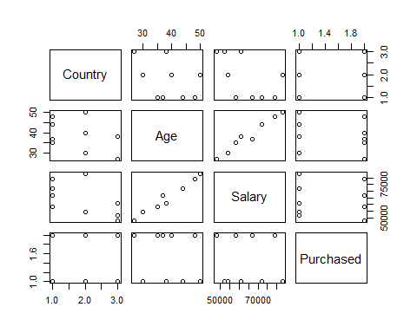

**Q.** Back Savers is a company that produces backpacks primarily for students. They are considering offering some combination of two different models—the Collegiate and the Mini. Both are made from the same rip-resistant nylon fabric. Back Savers has a long-term contract with a supplier of the nylon and receives a 5000 square-foot shipment of the material each week. Each Collegiate requires 3 square feet while each Mini requires 2 square feet. The sales forecasts indicate that at most 1000 Collegiates and 1200 Minis can be sold per week. Each Collegiate requires 45 minutes of labor to produce and generates a unit profit of $32. Each Mini requires 40 minutes of labor and generates a unit profit of $24. Back Savers has 35 laborers that each provides 40 hours of labor per week. Management wishes to know what quantity of each type of backpack to produce per week.

The company must produce ***X*** collegiate bags and ***Y*** mini backpacks per week to maximize the profit.

1. Since each collegiate generates $32 profit and each mini bag generates $24 profit, so total profit is given by: ***Z = $(32x + 24y)***

2. Since, each collegiate requires 3 sq. ft and mini requires 2sq. ft of nylon fabric, so total nylon fabric needed is:

***(3x + 2y) Sq. feet***

***3x + 2y <= 5000*** (Practical Condition)

3. Sales estimates that 1000 collegiate and 1200 mini can be sold in a week. Hence,

***X <=*** ***1000***

***y <= 1200***

4. Total time required to produce ***X*** collegiate and ***Y*** minis backpacks is-

***[ 1000 * 45 X + 1200 * 40 Y ]*** (total minutes of labor required per week)

***[ 1000 (45/60) X + 1200 (40/60) Y ]*** (Converting it into hours per week)

5. Now, available labor count is 35 and each can provide work for 40 hours in a week. Assume ***n*** is the number of workers working for the production collegiate bags, then ***35-n*** workers working on mini bags.

***( n * 40 + (35-n) * 40 )*** (hours)

***n * 40 + (35-n) * 40 <= 1400*** (Practical condition)

6. Based on the equations on 4 and 5,

***1000 (45/60) X + 1200 (40/60) Y <= 1400*** (hours)

1. **Clearly define the decision variables**

X and y are the decision variables – X represents collegiate, and Y tags the mini backpacks. While n is tagged for the number of workers assigned to the production of collegiate bags.

1. **What is the objective function?**

The main objective function is maximizing the profit of the company over the sales of 2 different types of products that it produces,

***Z = $(32x + 24y)***

Z is the objective variable defining the objective function.

1. **What are the constraints?**

From the set of linear equations describing the whole problem.

1. X and Y are set of constraint variables defining the objective variables ***Z.***

Values of both X and Y are limited as in ***X <=*** ***1000 , y <= 1200.***

1. Another constraint from the LP is – ***n.*** Variable defining the distribution of work force between the production of 2 separate products.

Values of n are limited as in ***n <= 35***

1. ***3x + 2y <= 5000***
2. ***1000 (45/60) X + 1200 (40/60) Y <= 1400***

|  |  |  |  |  |  |
| --- | --- | --- | --- | --- | --- |
| Resources | Resources usage per unit of activity | | | | Amount of resources available |
| Activity | | | |
|  | Collegiate (x) | Mini (Y) |  |  |
| Nylon  (sq. ft) |  | 3 | 2 |  | 5,000  (sq. ft) |
| Labor  (hours) |  | 45/60  = 3/4 | 40/60  = 2/3 |  | 1,400  (Total labor-hours) |
| Contribution to Z per unit of activity |  | 32 | 24 |  |  |